[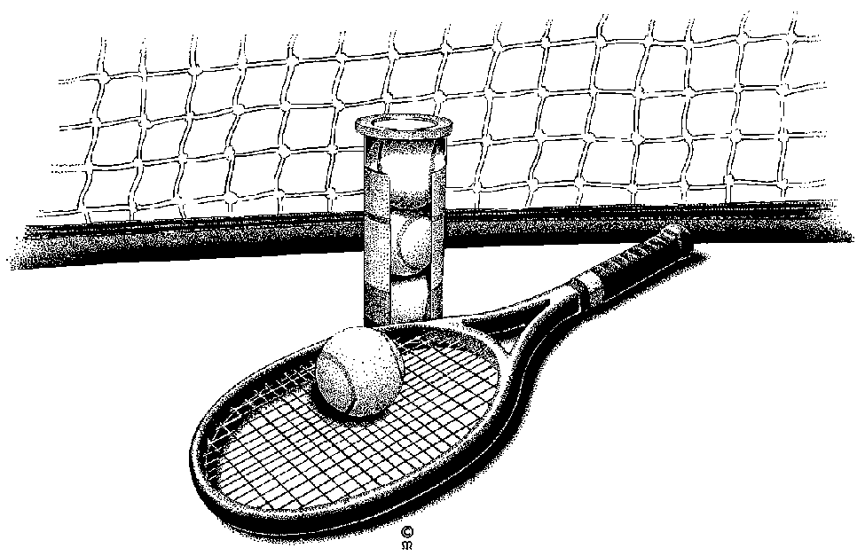](http://www.google.com/url?sa=i&rct=j&q=&esrc=s&source=images&cd=&cad=rja&uact=8&ved=0CAcQjRw&url=http://vintagetennis.com.au/coaching/private/&ei=IZ2QVcr1NJCKyATEvIDYDQ&bvm=bv.96783405,d.cGU&psig=AFQjCNF1VD2-E5ExGz7-vDpUJUiTKgiGYg&ust=1435627115556076)8th ANNUAL YOUTH TENNIS TOURNAMENT

**Events**

Boys JV Boys Varsity Girls JV Girls Varsity

**Event, Dates and Start Times**

Varsity Girls Singles on Monday, July 25th (8:30am)

Varsity Boys Doubles on Monday, July 25th (11:00am)

**Tuesday**

Varsity Boys Singles on Tuesday, July 26th (8:30am)

Varsity Girls Doubles on Tuesday, July 26th (11:00am)

Junior Varsity Boys Doubles on Tuesday July 26th (1:00pm)

Junior Varsity Girls Doubles on Tuesday, July 26th (2:00pm)

**Wednesday**

Junior Varsity Girls Singles on Wednesday, July 27th (8:30am)

Junior Varsity Boys Singles on Wednesday, July 27th (11:00am)

**Fees/Information**

$30 entry fee for each event you enter. Please provide a can of Wilson or Penn tennis balls as well for each event you enter. You will be **guaranteed 2 matches!!!** For any additional tourney information and updates please visit [www.lotustechnical.com](http://www.lotustechnical.com).  **Proceeds from the tournament will be going to scholarships to help tennis participants with their college education. We will be handing out scholarships in the summer of 2023.**

**Location**

The tournament will be held at the Rogers Tennis Club located at 21095 147th Avenue, Rogers, MN 55374. Matches will be held rain or shine!!!

_ _ _ _ _ _ _ _ _ _ _ _ _ _ _ _ _ _ _ _ _ _ _ _ _ _ _ _ _ _ _ _ _ _ _ _ _ _ _ _ _ _ _ _ _ _ _ _ _ _ _ _ _ _ _ _

(TO ENTER, complete and return bottom of form below, and have it to us by Friday, July 8th, 2022.

**REGISTRATION FORM**

NAME(S):___________________________________________________________________________

DOUBLES PARTNER:________________________________________________________________

PHONE #:___________________________________________________________________________

ADDRESS:__________________________________________________________________________STATE/ZIP:_________________________________________________________________________

EVENT(S)(Doubles partner):__________________________________________________________________________

EMAIL ADDRESS FOR UPDATES:_____________________________________________________ CAN WE TEXT YOU UPDATES: Yes / NO

Circle your T-shirt size (men’s sizes): small medium large X-large

Most recent position held on tennis team: __________________________________________________

FEE(S): $______________ (make checks out and mail to: Brian Rousslang, 7100 Northland Circle, Suite 105 Minneapolis, MN 55428. **(NO REFUNDS)**

Please have a parent or guardian sign below as a “waiver” for any possible injuries that might occur: **X**_________________________________________________________

For any questions please contact:

Brian Rousslang at 612-481-9955; [brousslang@lotustechnical.com](mailto:brousslang@lotustechnical.com)

or Ryan Kadelbach at 320-282-3270